Operation Steps for Client Update UKey Certificate
1. You need to log in Internet Banking
1) If the validity period is more than 90 days, click the update button to indicate that the time is not up and updating cannot be conducted.
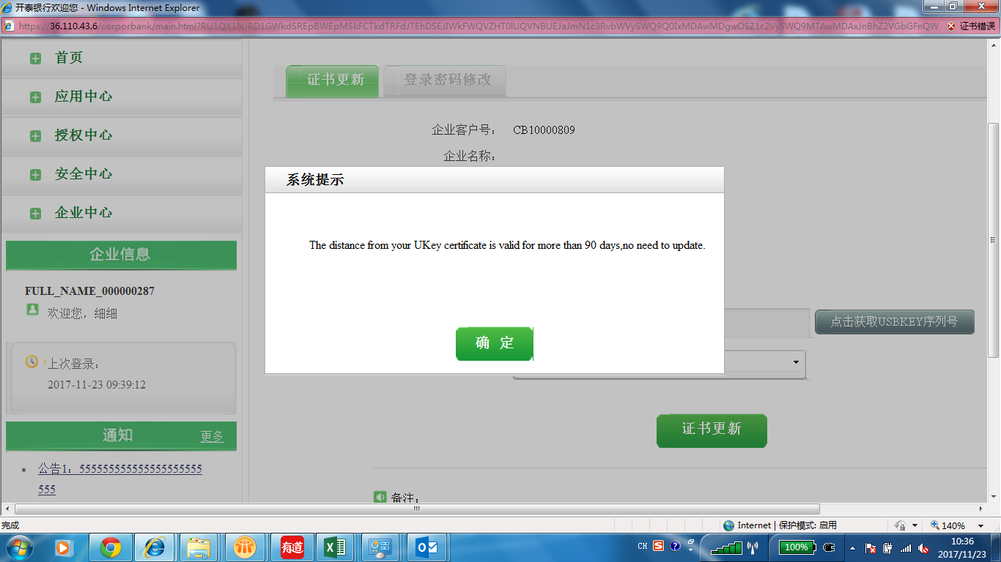
2) If the validity period expires within 90 days, the system will automatically pop up a dialog box to indicate that the certificate needs to be updated after you log in the system.
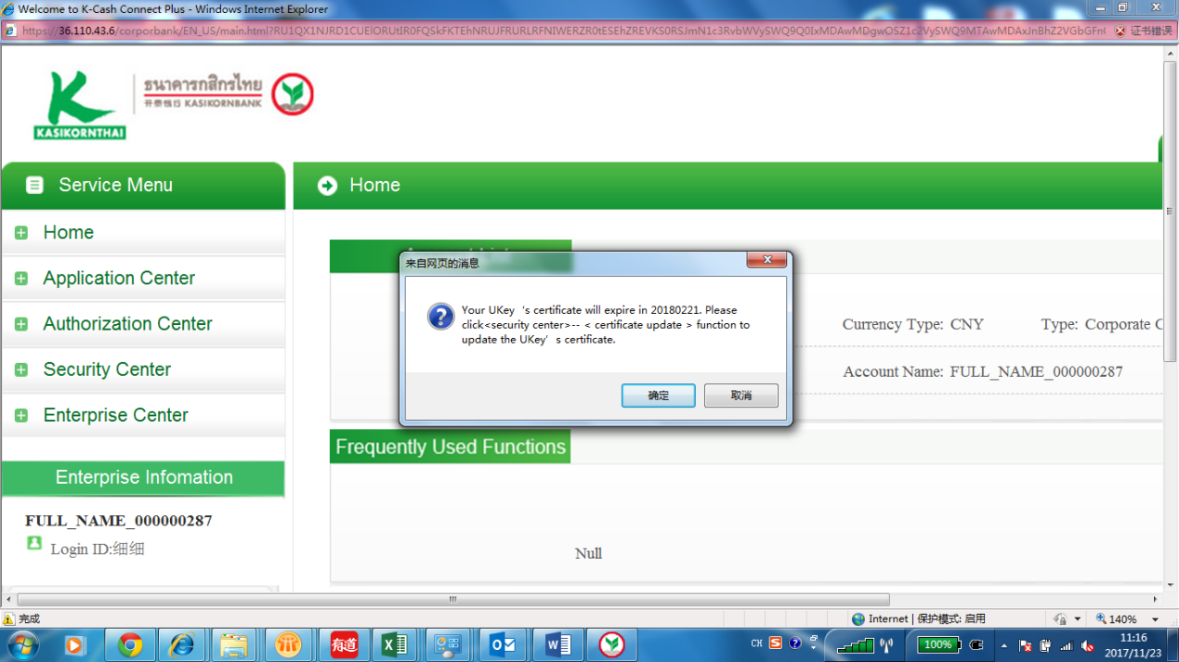
3) If you didn't update at that time, you can go to the "Security Center" – "Certificate Update".
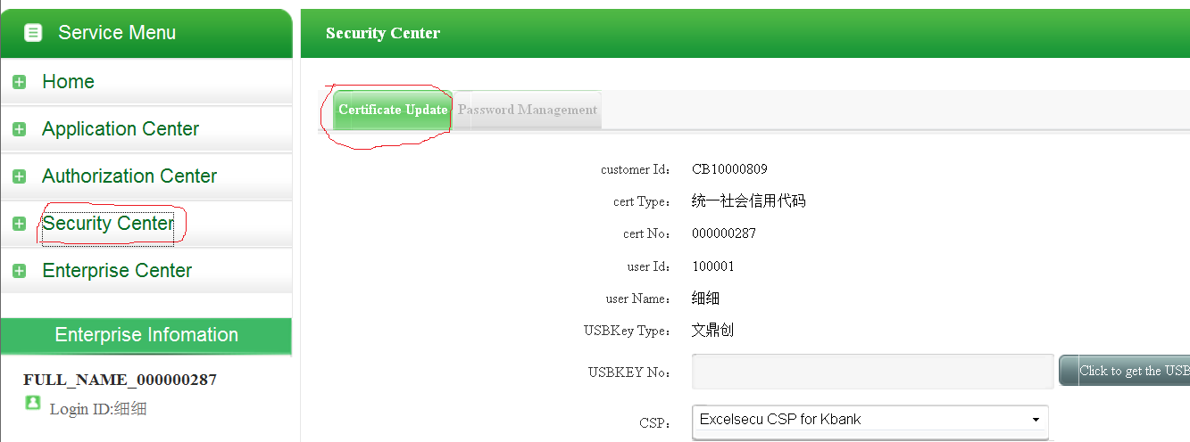
4) You need to install the plug-in, click the certificate "Obtain USBKey No. "and then click the update button.
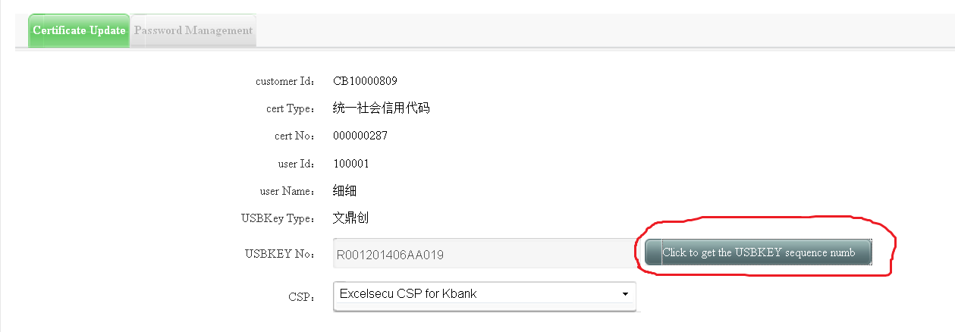

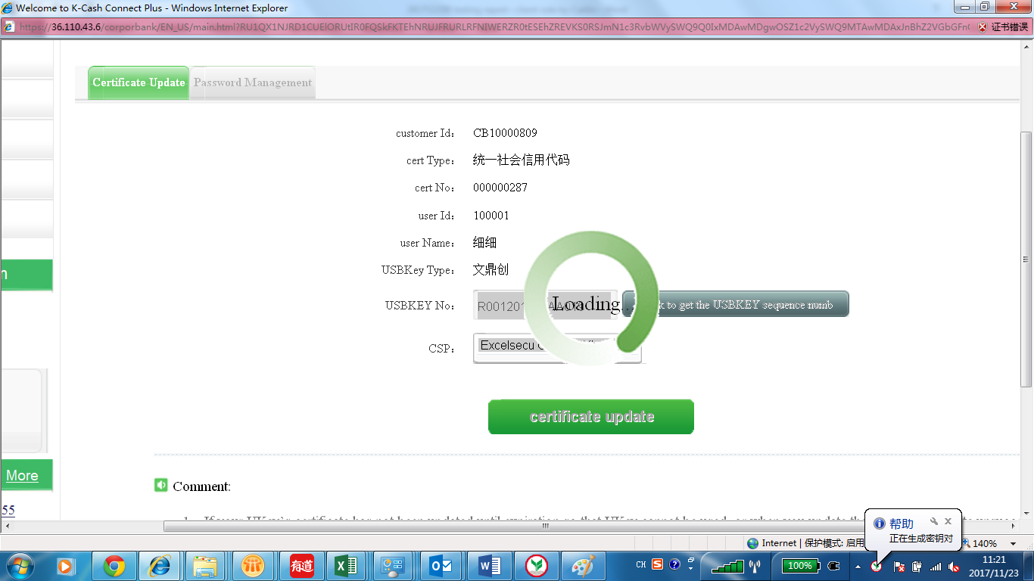
5) If the update succeeds, a prompt will be given. Please don't unplug UKey during update.
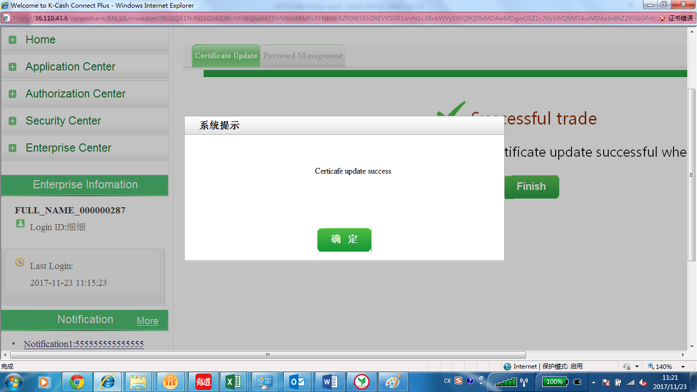
6). The certificate will be activated after 30 minutes, and then it can be used normally.
